CYBIT110 Chapter 6 Skills Assessment 1 - Devices and Device Drivers

Objective
Understand devices and device drivers on Windows and Linux operating systems.

Required Equipment
- Windows 11 VM
- Ubuntu VM

Part 1 Adding a Windows Printer
In Windows 11, a USB printer will be detected automatically, but you need to manually install network printers. In this part, you install a new network printer from Settings.
- Power on the log on to the Windows 11 VM.
- Click the Start button and click Settings.
- In the Settings window, in the left pane, click Bluetooth & Devices.
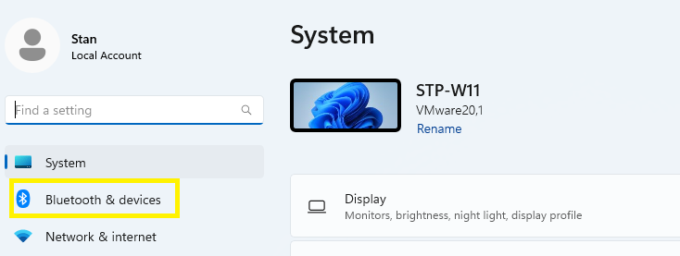
- In the right pane, click Printers & scanners.
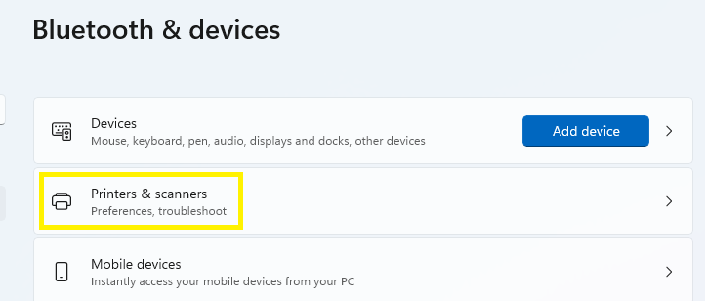
- Click Add Device button. Windows takes a few minutes to scan the network to attempt to find printers and display any printers that are found.
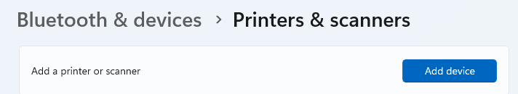
- Under The printer that I want isn’t listed, click the Add manually link
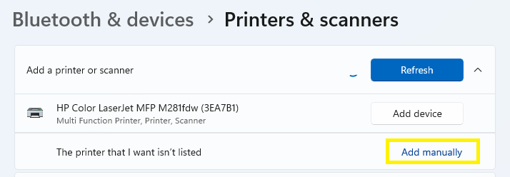
- In the Add Printer window, click Add a printer using a TCP/IP address or hostname and click Next.
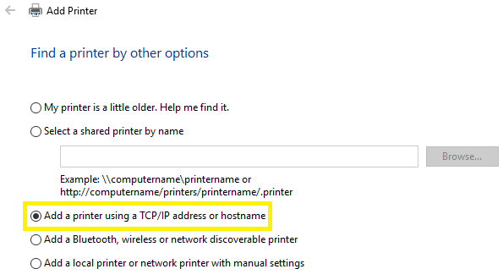
- In the Device type list, select TCP/IP Device.
- In the Hostname or IP address box, type 172.16.25.25. There is no printer at this IP address; it is chosen for the purposes of the assessment only to see the interface.
- Uncheck the Query the printer and automatically select the driver to use check box and click Next. In most cases, you want to leave this option on. You are deselecting it because we are simulating the process.
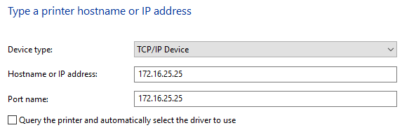
- It will be a few minutes once the Detecting TCP/IP port has completed detecting.
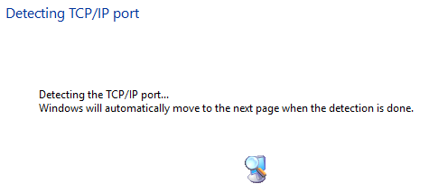
- On the Additional port information required page, leave as Standard and click Next.
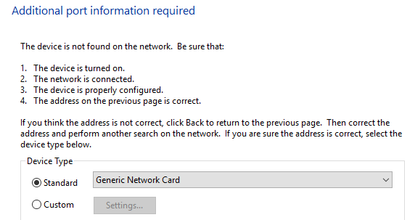
- In the Install printer driver, if you have only the two to three manufacturers listed, click Windows Update button.
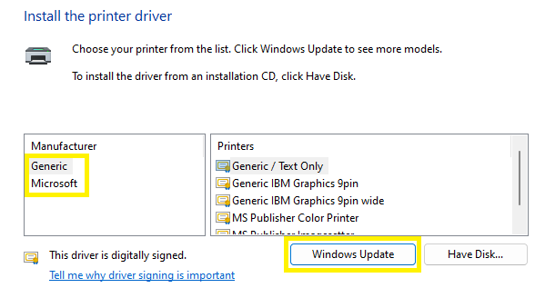
- Windows will update the list of printers. It might take up to ten minutes
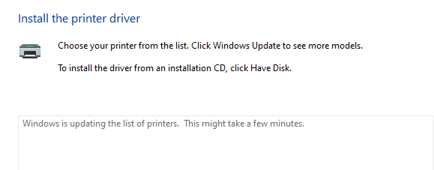
- Once the Manufacturer section populates with more entries, select HP. In the Printers box, scroll to the bottom and select HP Universal Printing PCL 6 and click Next.
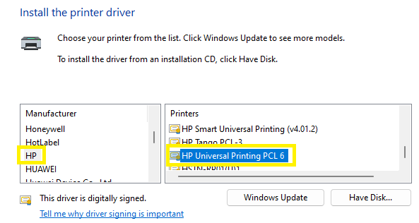
- In the Printer name box, type HP Printer-XX (XX will be your initials) and click Next. It will take a few minutes while the printer is installed.
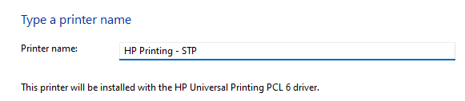
- On the Printer Sharing page, click Do not share this printer and click Next.
Note: The printer can be shared later by accessing the printer properties
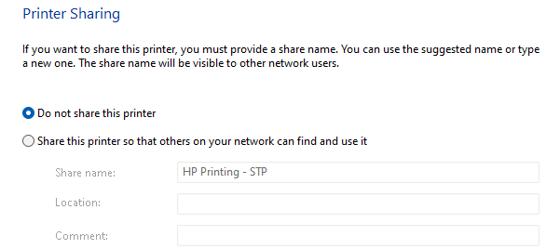
- In the Successfully added page, click Finish.
- In the Printers & scanners window, the new printer will be listed.
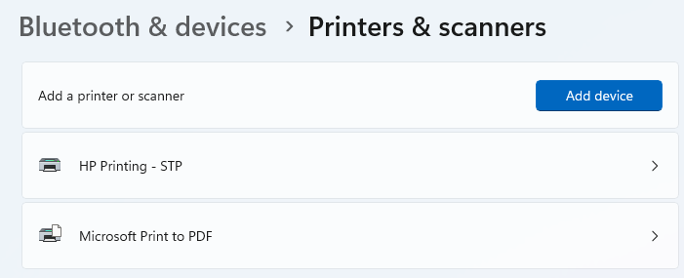
- Insert a screenshot showing the new printer in Printers & scanners page.
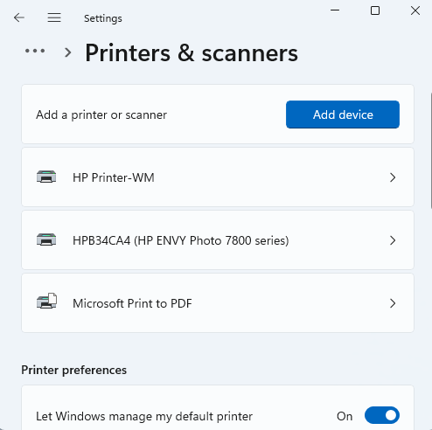
- Close the Settings window.

Part 2 Using Windows Print Management MMC
Print Management is a Microsoft Management Console (MMC) snap-in that enables you to install, view, and manage all of the local and remote printers and print servers. Print Management provides up-to-the-minute details about the status of printers and print servers on the network.
- Right-click the Start button, in Search, type print man, and click Print Management.
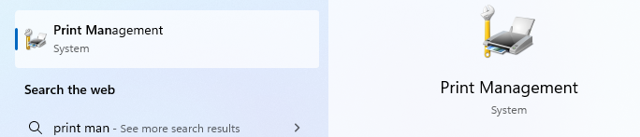
- If necessary, in the left pane, expand Custom Filters and click All Printers. This filter displays all of the printers installed on every print server that is being monitored. In this case, only the local printers are displayed because only the local computer is being monitored.
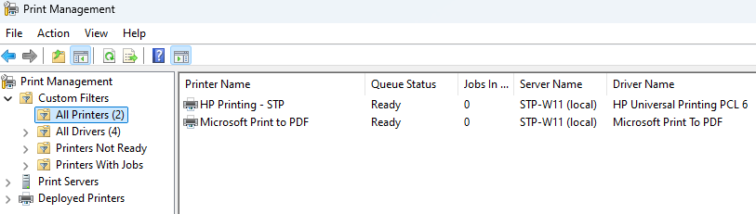
- Insert a screenshot showing the Printer Name section showing your new printer.
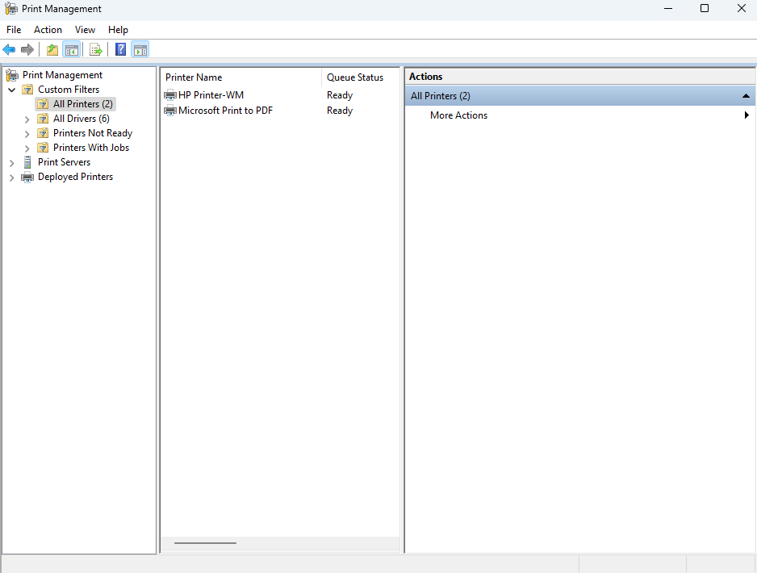
- In the left pane, click All Drivers. This filter displays all of the printer drivers that are installed on every print server that is being monitored. This allows you to see if different printer driver versions are installed on various print servers.
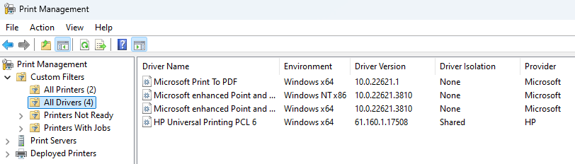
- In the left pane, if necessary, expand Print Servers, expand your computer, and click Drivers. This node displays only the printer drivers that are installed on your computer.
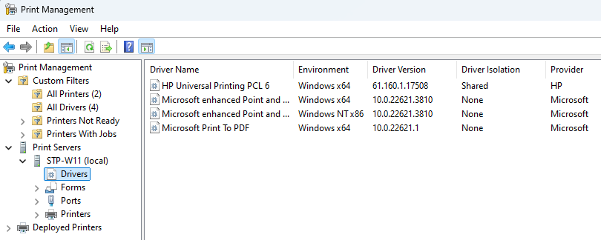
- In the left pane, click Ports. This node displays all the ports configured on your computer that can be used for printing. You can add additional ports or manage existing ports from here.
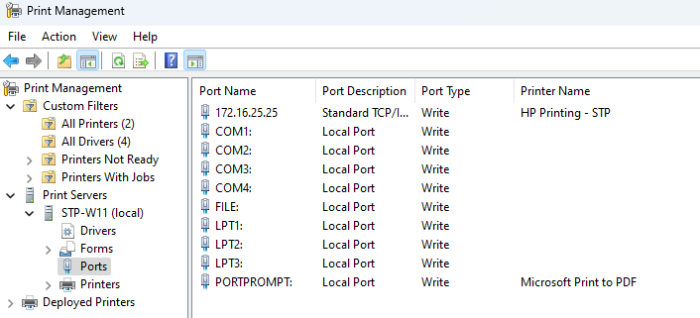
- In the left pane, click Printers. This node displays all of the printers that are installed on your computer. You can manage the printers from here and install new printers.
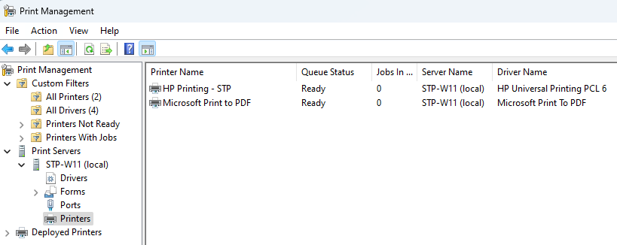
- Close all open windows.

Part 3 Using Windows Device Manager and System Information
Device Manager is an MMC snap-in that can configure hardware components and device drivers. You can use it to install updated drivers and disable devices that are not functioning properly. When opening the Device Manager, all categories should have “+” or arrows pointing to the right “>” next to each of the device categories with no Other devices or Unknown devices listed. However, when problems occur, you can identify the errors with the following:
  - An exclamation mark under "Other devices", this indicates that the device is conflicting other hardware. Or, it may indicate that the device, its drivers are not installed properly, or no device driver is loaded.
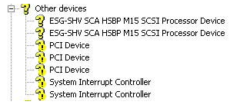
  - Red X -The device has been disabled, removed, or Windows is unable to locate the device.
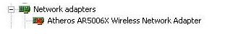
  - Down arrow - In Windows Vista, 7, and later, if you see a small down arrow next to the device as shown in the picture, this is an indication that the device has been disabled.
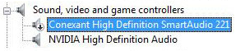
  - Unknown device -If devices are being detected but are showing in Device Manager as an Unknown device, this is an indication that Windows does not have the proper driver support for that device.
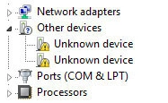
  - Missing hardware- If you do not see the device you are trying to install in Device Manager, and there are no "Other devices" listed, this is an indication that the device is not being detected. Even if Windows does not have the proper driver support for the device, it should still put that device under "Other devices" or "Unknown device."

- Right-click the Start button and click Device Manager.
Note: Device Manager is also included in the Computer Management administrative tool.
- Expand Network adapters and double-click your network card to display the Properties dialog box (the name of the network card will vary depending on your hardware).
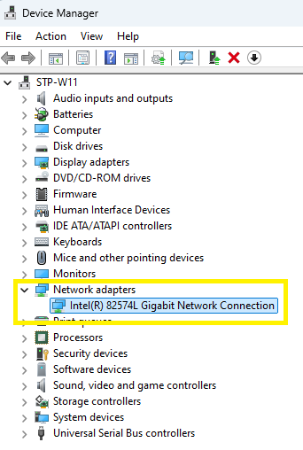
- The General tab gives general information about your network card, including its status.
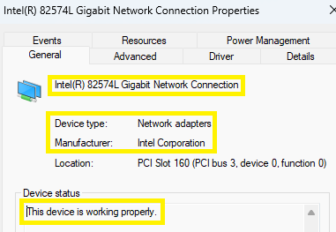
- Insert a screenshot showing the network adapter properties.
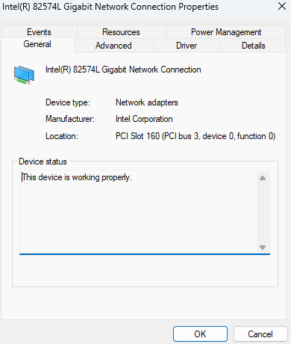
- Click the Advanced tab. The contents of the Advanced tab vary depending on the model of network card. The settings are defined by the device driver.
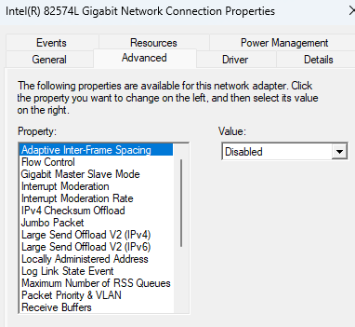
- Click the Driver tab. This shows information about the device driver, including date, version number, and publisher.
You can also update drivers or roll back drivers here.
  - The Driver Details provides additional information such as the filename of the driver and where it is located on the hard disk.
  - The Update Driver button is used to obtain an updated driver or install a driver if one is not already installed.
  - The Roll Back Driver button is used to revert the driver to a previously installed driver if there is a problem with an updated driver. (This button is disabled/grayed out if you are installing the first driver.)
  - The Disable Device can disable a device without actually installing it.
  - The Uninstall Device button is used to remove a driver.
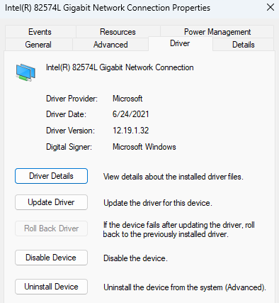
- Where is the driver file located for your network adapter?
C:\Windows\system32\DRIVERS\e1i68x64.sys
- What two options do you have for updating the driver?
Search automatically for drivers or Browse my computer for drivers
- Click the Details tab. The Details tab has an option box that lets you select and view all of the device driver details. Under Property, browse through the list of details you can view.
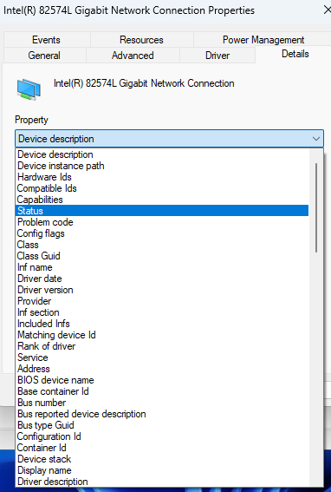
- Select Install date. The output will display when the driver was first created.
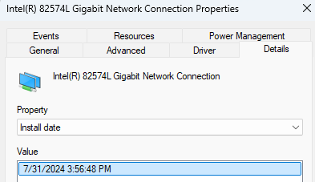
- Insert a screenshot of the result.
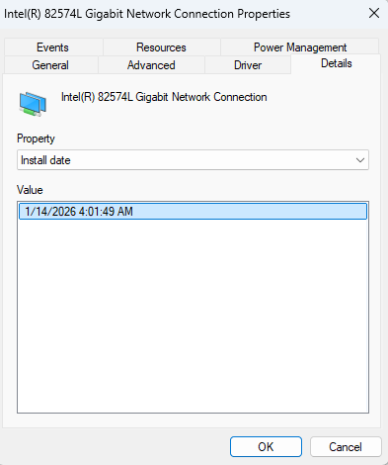
- Click the Events tab. This tab displays information about actions taken by the device, such as loading or starting the device driver.
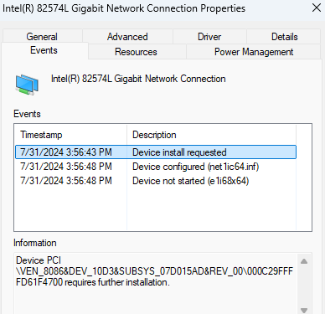
- If present, click the Resources tab. You can view and modify the resources used by a device on this tab. A message at the bottom of the dialog box tells you if any conflicts are detected. This tab might not be available if your Windows 11 installation is virtualized. Here is a breakdown of the Resource setting section:
  - Memory Range is used to reverse physical memory for the component such as the network adapter as shown below. The size will also vary. It can have more than one range. It is identified in hexadecimal characters
  - IRQ or Interrupt Request Line is signal sent by a device to get the attention of the processor when the device is ready to accept or send information. Each device sends its interrupt requests over a specific hardware line. Each device must be assigned a unique IRQ number.
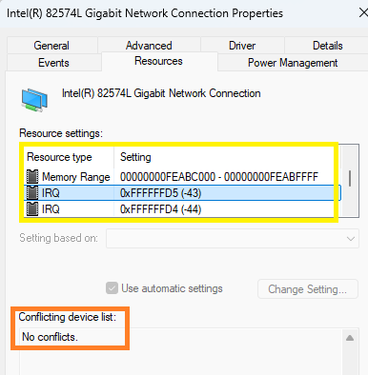
- Insert screenshots showing the memory range and the IRQ.
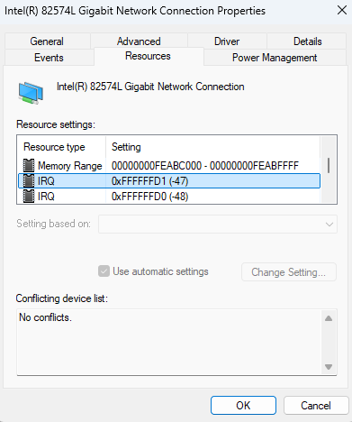
- Click Cancel.
- Close Device Manager.
- The System Information (or msinfo32) tool displays configuration details about your computer, including information about the main components, hardware resources such as driver information, and system software.
- Press Right-click Start and click Run.
- In the Run dialog box, type msinfo32 and click Enter. Note: You can also type in Search bar – System Information for the same screen.
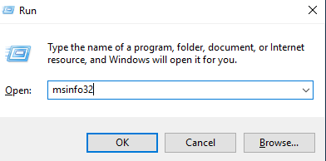
- System Information screen appears.
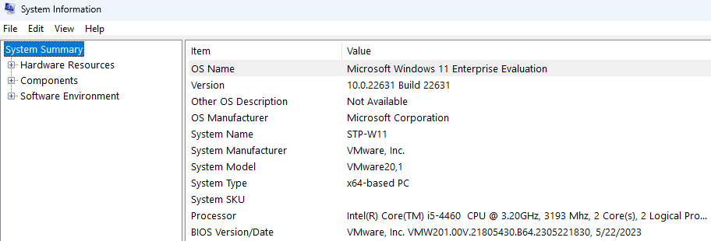
- Click on Hardware Resources -> I/O. Look for the network adapter. I/O range is a range of addresses (channel) through which data is transferred between a device and the CPU. The port appears to the CPU as one or more memory addresses that it can use to send or receive data. It is identified in hexadecimal characters
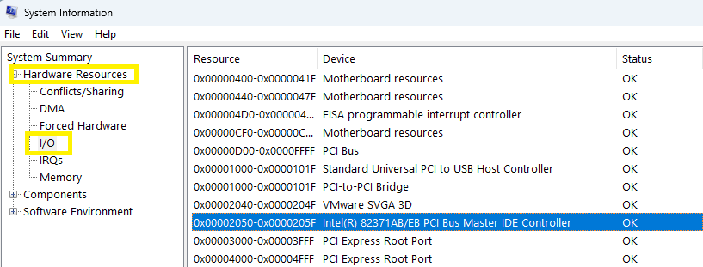
- Click on IRQs. The network adapter IRQ will be listed.
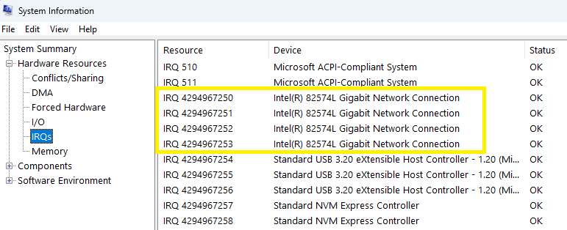
- Click on Memory. The address ranges should be the same as in Device Manager without the extra leading zeros.
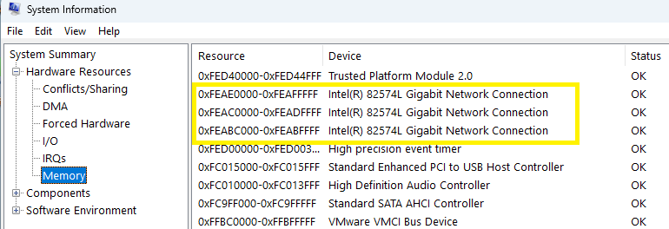
- Click Components -> Network -> Adapter. Scroll down to view all of the information from Hardware Resources. It will have the memory address and the IRQ channels.
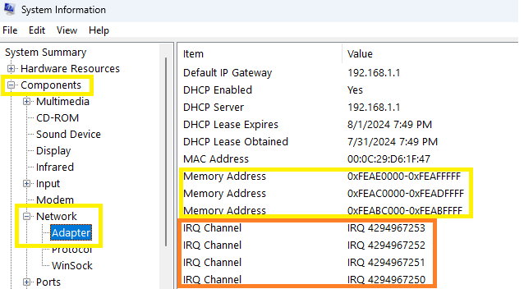
- Insert a screenshot show the Memory Address and IRQ channel information.
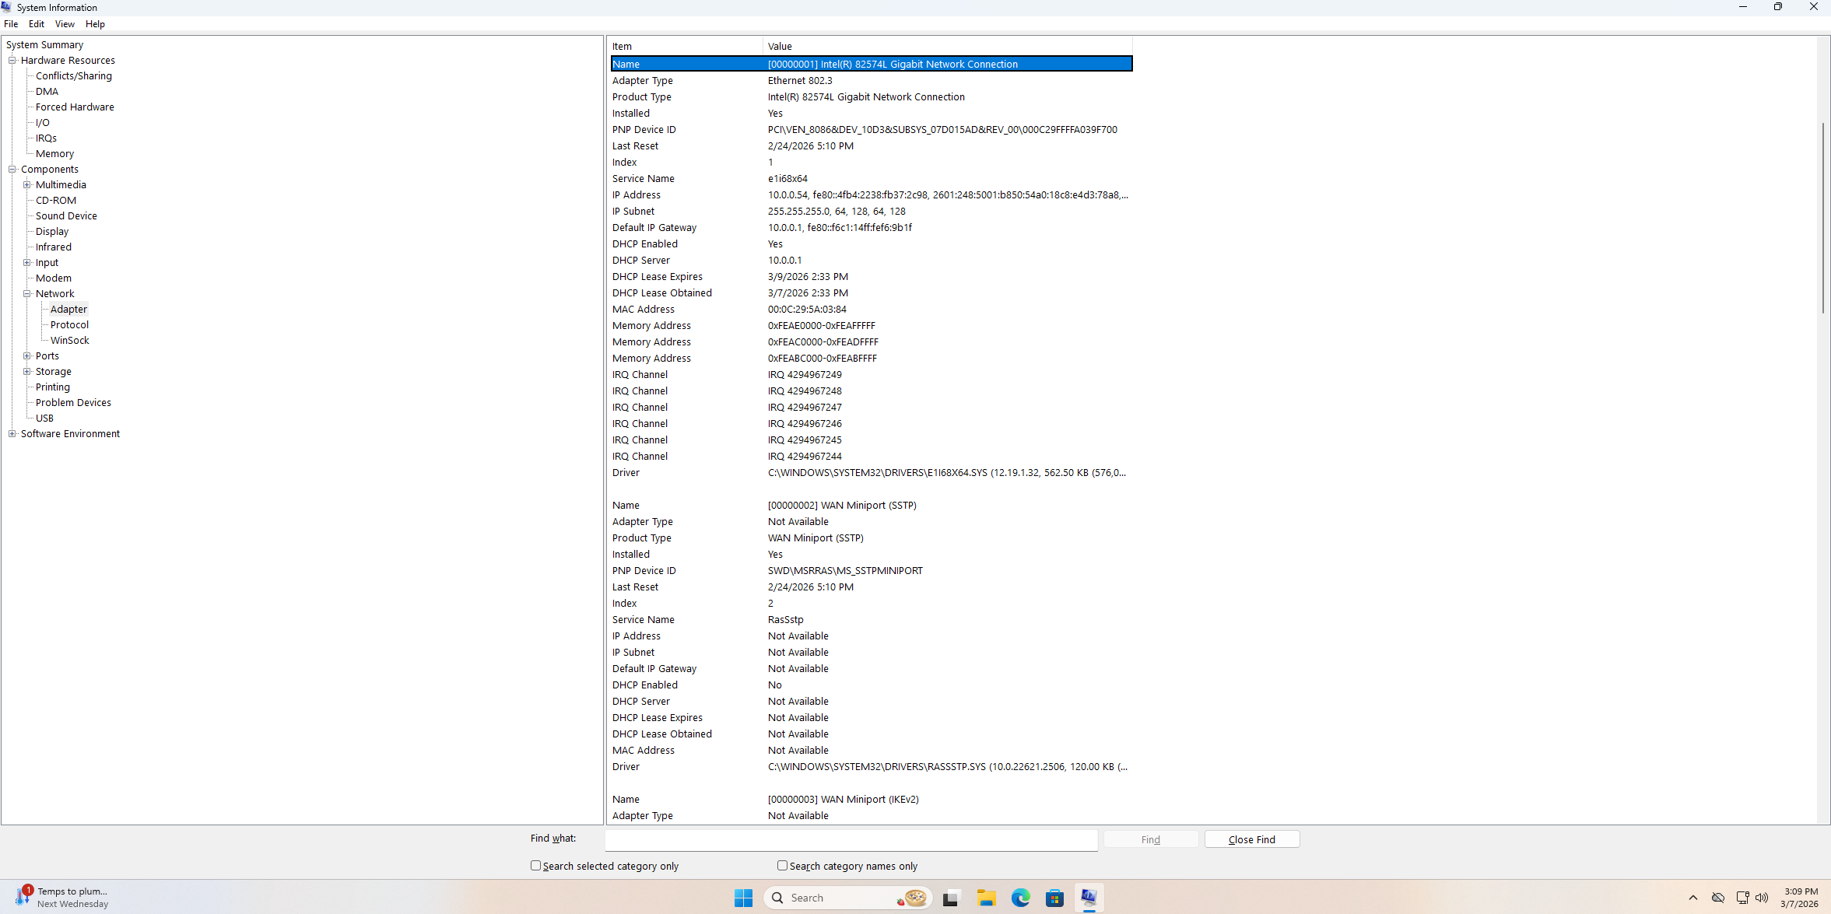
- Close System Information window.
- Shutdown Windows 11 VM.

Part 4 Viewing Devices in Linux
In this part, you examine the contents of a folder using Ubuntu Linux. Then, you use the lshw command to view a detailed listing of hardware.
- Power on your Ubuntu VM and log on.
- Open a terminal window. Type ls -l /dev and press enter. Scroll through to see a listing of device special files.
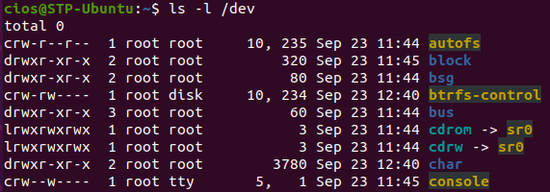
- In Linux ls command, the yellow with black background is a device.
Note: Within Linux devices such as hardware are characterized in two ways:
  - Character Devices (c) which are devices which transfer data in characters also known as bytes or bits such as mice, speaker etc.
  - Block Devices (b) which are devices which transfer data in blocks of data such as USB, Hard Disks etc.
- A hard drive is a block device. To filter only for hard drive, type the command ls -l /dev | grep sd and press Enter.
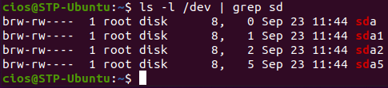
- Insert a screenshot of the result.
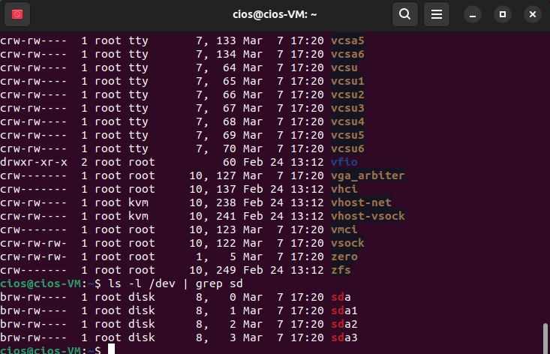
- The lshw (list hardware) command is a Linux utility which is used to generate the detailed information of the system's hardware configuration from various files in the /proc directory. Type the command: sudo lshw and press enter. If necessary, you might be prompted to enter the password P@ssw0rd.
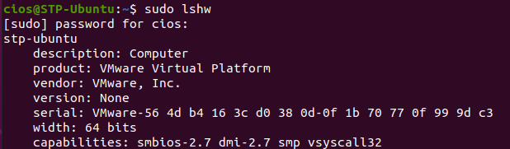
- Scroll through the listing of devices. You’ll see entries for motherboard devices, including the CPU.
- An option is available in lshw called class which will shows specific given hardware information in detailed manner. To view only disk devices, type lshw –class disk and press enter. The output will display the cdrom and disk hardware information.
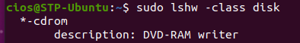
- Insert a screenshot of the result.
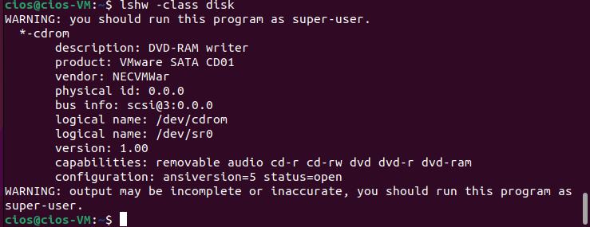
- Close the terminal window.
- Stay logged for the next part.

Part 5 Adding a Network Printer in Linux
In this part, you install a network-attached printer using the GNOME Printers tool. Your instructor will give you the name or address of the network printer. Then, you use the CUPS Web-based administration tool to view printer and job status.
- Click Show Applications, and then click Settings.
- Click Printers.
- To add a new printer, click Add New Printer. If a printer is already installed, click the plus sign in the lower-left corner to install a new printer.
Note: If Ubuntu cannot find it, you need to type the address or DNS name of a network-attached printer and press enter. Linux probes the printer and, if found, displays the printer model at the top of the screen.

- Select CUPS-BRF-Printer and click Add. The CUPS printer will be added.
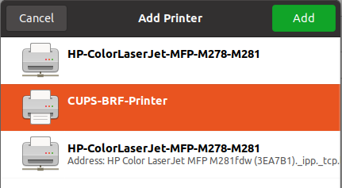
- Insert a screenshot of the result.
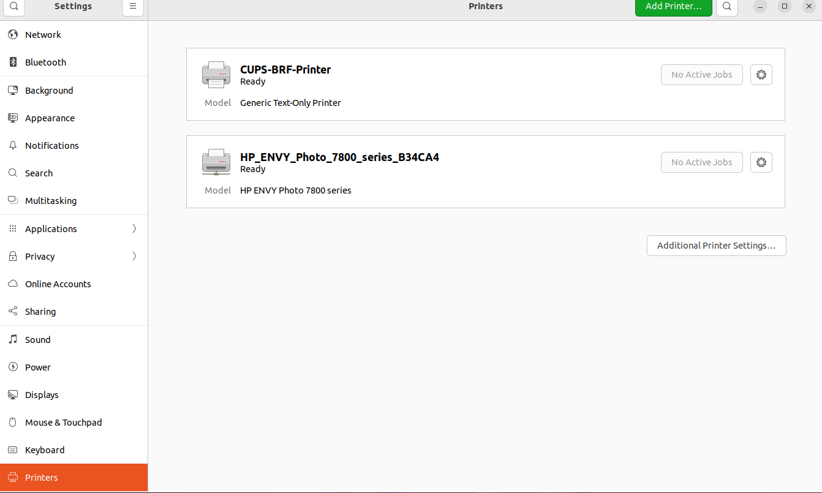
- Close the Printers window.
- Common Unix Printing System (CUPS) is a printing system used on many different Linux distributions. Its use is very widespread, as it has become the standard print manager on the majority of popular Linux distros. It acts as a print spooler, scheduler, print job manager, and can store information for numerous local or network printers.
- There is a CUPS web interface that runs on port 631. Open a Web browser. In the address bar, type http://localhost:631 and press enter. The CUPS administration page opens.
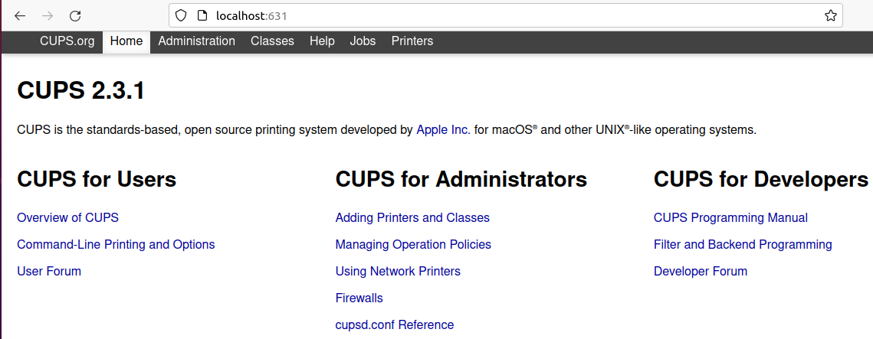
- When you first access the CUPS web browser interface, you see the Home tab. From this tab, you can access all of the print administration tasks, which are grouped together by category, as well as the full set of CUPS documentation.
- The following tabs are displayed on the web browser interface's main web page:
  - Administration – Enables you to access most print administration tasks, including CUPS server configuration.
    - You can directly access the Administration section of the web browser interface by going to http://localhost:631/admin.
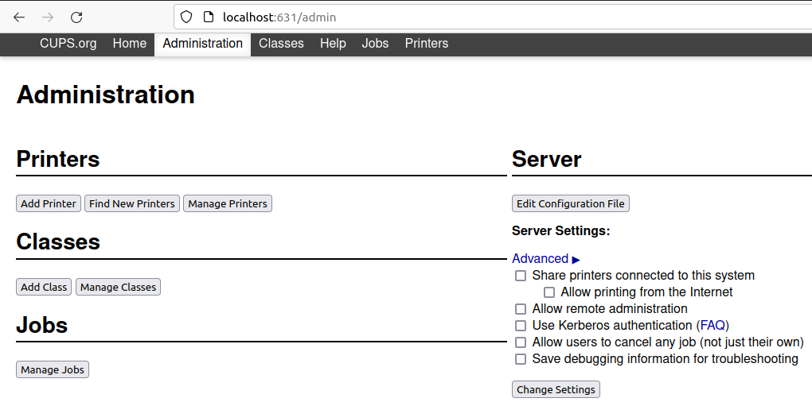
  - Classes – Enables you to search printer classes.
    - CUPS provides collections of printers, which are called printer classes. Print jobs that are sent to a class are forwarded to the first available printer in that class. Classes can be members of other classes. Therefore, you can define very large, distributed printer classes for high-availability printing.
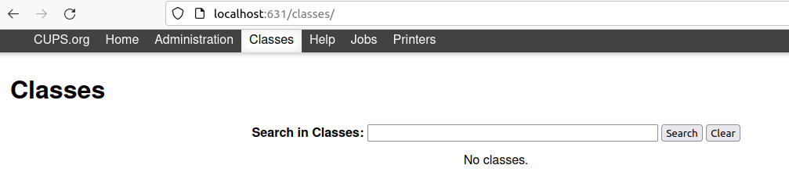
  - Help – Enables you to access the CUPS documentation, which includes manuals, system administration documentation, FAQs, and online help.
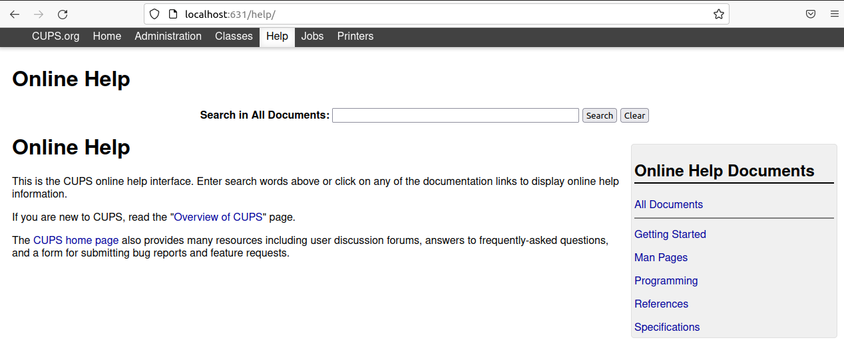
  - Jobs – Enables you to view and manage print jobs for configured printers.
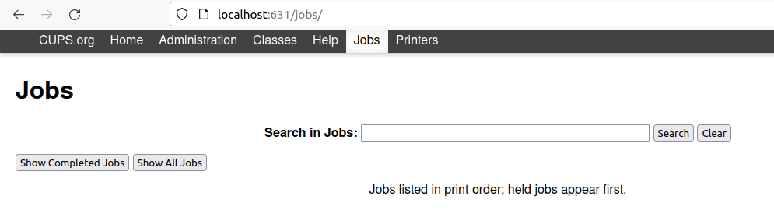
  - Printers – Enables you to view information about and modify the settings of a specified printer.
- Open the Printers tab. Click CUPS-BRF-Printer.
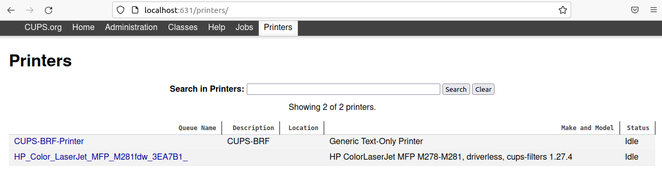
- There are drop-down menus for Maintenance and Administration.
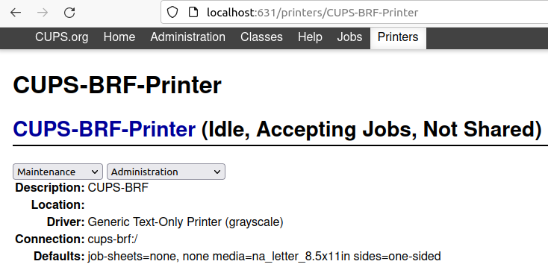
- What are the options in Maintenance?
Print Test Page, Pause Printer, Reject Jobs, Move All Jobs, Cancel All Jobs
- What are the options in Administration?
Modify Printer, Delete Printer, Set Default Options, Set As Server Default, Set Allowed Users
- Close the CUPS web interface.
- Open a terminal.
- The lpstat command displays status information about the current classes, jobs, and printers.
- To see the list of printers and their attached devices, type the command: lpstat –v and press enter. In the case of network printers, you will see their IP addresses.
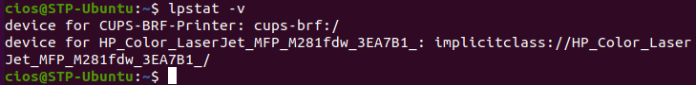
- To see the status of your printers, type the command lpstat -p and press enter.
- Insert a screenshot of the result.
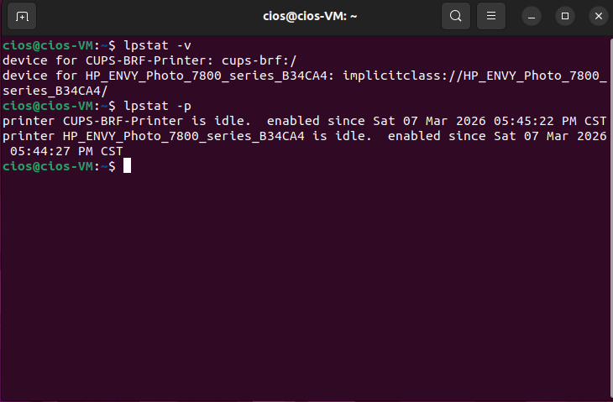
- Close the terminal window.
- Shut down the VM.

Resources
https://www.computerhope.com/issues/ch001212.htm
https://www.computerhope.com/jargon/m/msinfo32.htm
https://docs.oracle.com/cd/E23824_01/html/821-1451/gllhj.html

Revisions
- 7/31/24 – Updated for Windows 11

